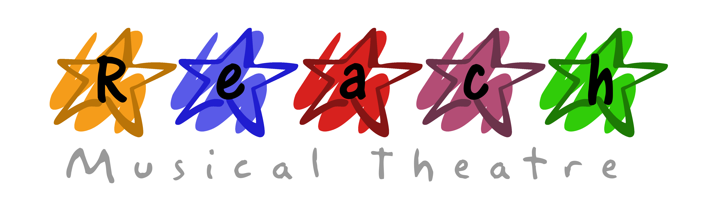

CODE OF CONDUCT
Reach Musical Theatre School
This code is designed to ensure all company members get the maximum fun and enjoyment out of their membership and to ensure that the production achieves the highest possible standard.
• All classes start promptly therefore you must be in the venue and ready to start by the published class start time.
• You must sign the attendance register on arrival and departure; this is for your own health & safety.
• If you miss three classes, during the term the Company reserves the right to withhold your place in the show.
• All rehearsals held in the last three weeks before the show must be attended, these rehearsals are vital to the success of the show.
• You must read and adhere to the Company Health & Safety Policy.
• You must inform us in writing of any injury or condition, which may affect your ability to perform.
• Litter must not be left in any rehearsal area or performance venue.
• No mobile phones are to be brought into lessons.
• For your safety, no chewing gum is permitted in rehearsals.
• Please bring your own refreshments to classes and rehearsals; these must be consumed during breaks.
• Sessions will be run in an atmosphere of discipline and fun, please listen to the instructions of the coaches.
• Please be polite and courteous to all members of the group, please report any intimidation, harassment or bullying immediately to a member of staff.
• Company t-shirts, black leggings or trousers and jazz shoes must be worn during classes and rehearsals.
- The recording of any part of the rehearsals or show by audio or visual equipment is strictly forbidden.
- All scripts, t-shirts and hoodies must be paid for before collection.
• Release, indemnity and authorisation to photograph, record and reproduce. I agree to allow the company to make audio and visual recordings and photographs of the likeness, voice and sounds of me in classes and at the event as well as publish my name and biographical information, and to use these as publicity medium in all forms.
Carla Jane Clayton - Director (reachmusicaltheatre@gmail.com)

